XREA Frontend documentation (reference)

Route Detail:
- Landing page/ start page
  - app.jsx (src/app)
    - home-view.jsx(src/modules/home)
      - home-details.jsx(src/modules/home)
        - info-card.jsx(src/shared/components/section-view)
        - insights-card.jsx
        - methodology.jsx
        - only-responsible.jsx
        - section-card.jsx
- Search Page
  - search-view(src/modules/search)
    - search-details.jsx(src/modules/search)
      - search-section.jsx(src/modules/search)
      - search-result.jsx(src/modules/search)
    - market-segment-view.jsx(src/modules/market)
- API
  - get-citylist.jsx – to populate city data in autocomplete (search criteria)
    - BaseUrl/users/search/city
      - Table : city_master
      - Column Name: geo_id, geographic_area_name
      - Filter Criteria: geographic_area_name, publication_year
  - get-usecase-list.jsx– to populate use cases in autocomplete (search criteria)
    - BaseUrl/ users/usecase
      - Table : use_case_master
      - Column Name: use_case_group_desc, use_case_id, use_case_group, priority_label
      - Filter Criteria: geographic_area_name, publication_year
  - city-search.jsx – to get data as per selected city and use cases.
    - BaseUrl/ search
      - Table : use_case_master, city_view_2020_updated, index_final_scores_new_1
      - Filter Criteria: use_case_group, geo_id

Overview of Folder Structure:
SRC folder contain 4 sections-
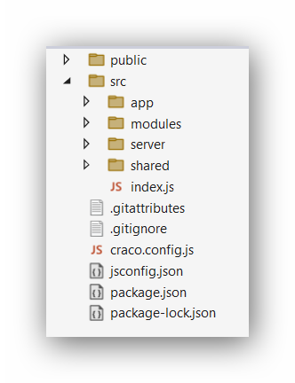
- app
- modules
- server
- shared
A) app
Contains initial styles and landing pages of the application
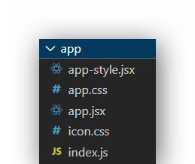
B) modules
Contains module wise deviation. All module have a *-view.jsx as landing component and others are associate components as needed.
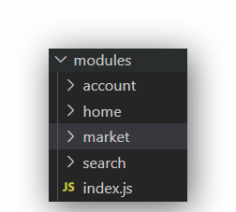
We have 4 modules-
- account module contains all user access related sub-modules, eg. Login, Sign-out etc.
- home module contains home-view and it’s details component. Details component has 4 card sections as InfoCard, InsightCard, OnlyResponsible, Methodology. All these 4 card components are coming from shared->components->section-view.
- market module contains view component of market-segment.
- Search module contains all the view components and associate component to get and display search result on city and others filters.
C) server
Contains all data transfer related components
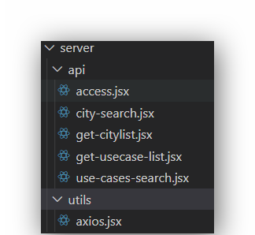
In API folder we have placed all the components related to manage data with apis.
D) shared
Contains all common components.
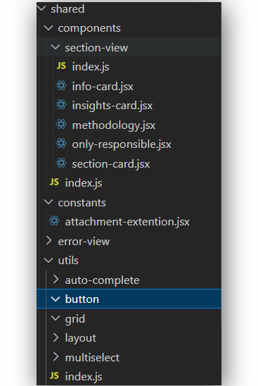

Route overview

We have Route in home-view.jsx in home module
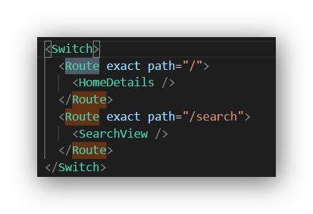
- HomeDetails-> home-details.jsx in home module
- SearchView-> search-view.jsx in search

